CONVERSION OF THE VEHICLE: TOYOTA HIACE HIGH ROOF AMBULANCE
A | PATIENT COMPARTMENT FITTINGS
1 | Insulation and covering of the patient compartment
2 | Partition with sliding glass window for communication.
3 | Cabinet for medical equipment & oxygen cylinders - Material: PVC
4 | Flooring made with marine grade plywood - 18 mm thick, sturdy non-slip, anti-static and liquid-resistant vinyl.
5 | Squad bench with under seat storage, backrest and seat belt - Capacity: 3- 4 persons
6 | Doctor Seat with Fixed backrest, Swiveling Mechanism, 3 point Automatic Safety belt
B | ELECTRICAL SYSTEM & COMPONENTS
7 | Electric wiring with insulation
8 | Electric control panel/fuse box
9 | 2x Socket 12V & 2x Outlet 220V
10 | Shore line with connection cable 15m and 220V oulet
11 | Roof type ventilation fan
12 | Reverse Alarm
13 | Video Recorder
14 | Air conditioning unit for the patient compartment
15 | Engine Heater
C | LIGHTING SYSTEM
16 | LED lighting for the patient compartment
17 | LED light bar with siren, speaker and microphone (color:as per customer requirements)
18 | Strobe lights at the back of the vehicle (color:as per customer requirements)
19 | Loading LED light
20 | Flexible LED Light
D | OXYGEN SYSTEM
21 | 2x 10L Oxygen cylinder, regulator, outlet, flow meter humidifier and oxygen mask
22 | Oxygen system related hoses
E | PATIENT TRANSPORT EQUIPMENT
23 | Automatic Loading Stretcher (CE Certified)
24 | 2 Nos. Foldable Stretcher (CE Certified)
25 | Spinal Board Long with head Immobilizer (CE Certified)
26 | Stair Chair (CE Certified)
27 | Fracture Splint (CE Certified)
28 | Cervical Collar (CE Certified)
F | MEDICAL EQUIPMENT
29 | First Aid Kit - 25 person (CE Certified)
30 | Wall Mounted Sphygmomanometer (CE Certified)
31 | Aneroid Sphygmomanometer (CE Certified)
32 | Stethoscope Dual Head (CE Certified)
33 | Syringes 3ml, 5ml, 10ml - Boxes (CE Certified)
34 | 20L Portable Suction Machine PMSA - 3A/Canada (CE Certified)
35 | AED Defibrillator HR-501 - Radian/South Korea (CE Certified)
36 | ECG Machine, 3 Channel E3 - 3A/Canada (CE Certified)
37 | BT-710 Pulse Oximeter Handheld woth Pediatric SPO2 Sensor - Bistos/South Korea (CE Certified)
38 | GM620 Blood Glucose Meter with Test Strips - Bionime/USA (CE Certified)
39 | UV Germicidal Lamp (CE Certified)
40 | Heating Blanket (CE Certified)
41 | Obstetric Kit (CE Certified)
42 | Anti-epidemic Kit/PPE Kit (CE Certified)
G | OTHER ACCESSORIES
43 | Fire Extinguisher 2kg
44 | Emergency Hammer with Seat Belt Cutter
45 | Emergency Portable Lantern/Light
46 | Side Reflective Lines
47 | All Text and Logos

48 | Glass Tinting
49 | 2 Nos. IV Hooks
50 | Sharps Container
51 | Class B Medical Waste Container 10L
52 | Safe Locker with keys

TOYOTA HIACE HIGH ROOF AMBULANCE (AFTER PRODUCTION)
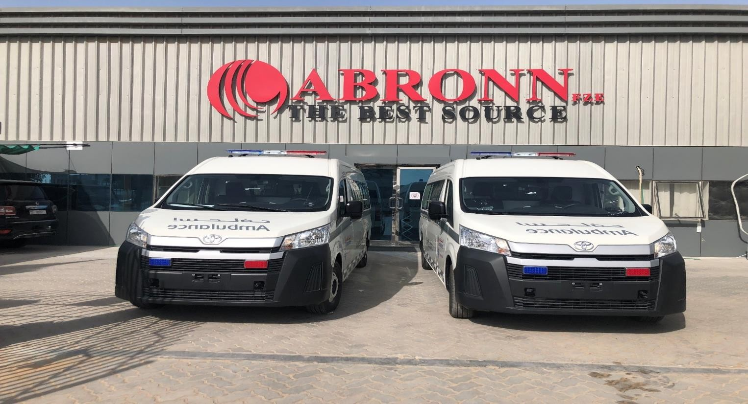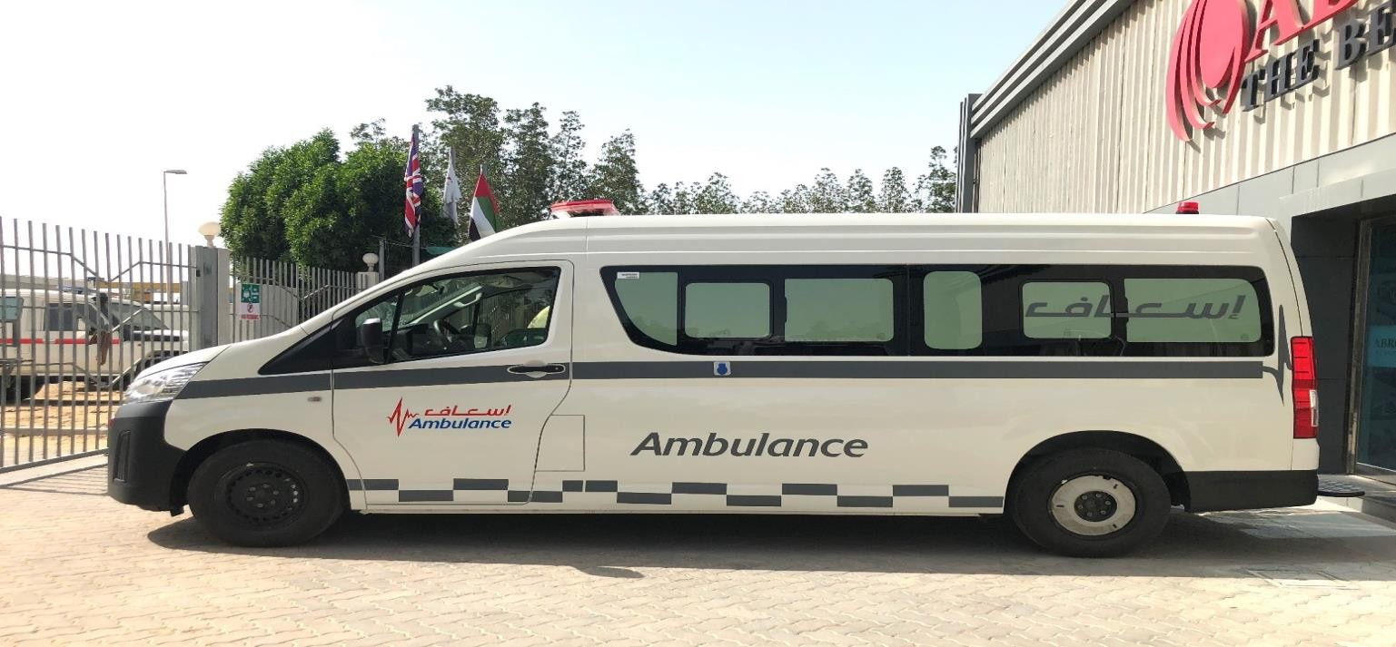

EXTERIOR
NOTE: PHOTOS SHOWN ARE FOR REFERENCE ONLY. FINAL PRODUCTION WILL BE BASED ON CLIENT'S REQUEST.

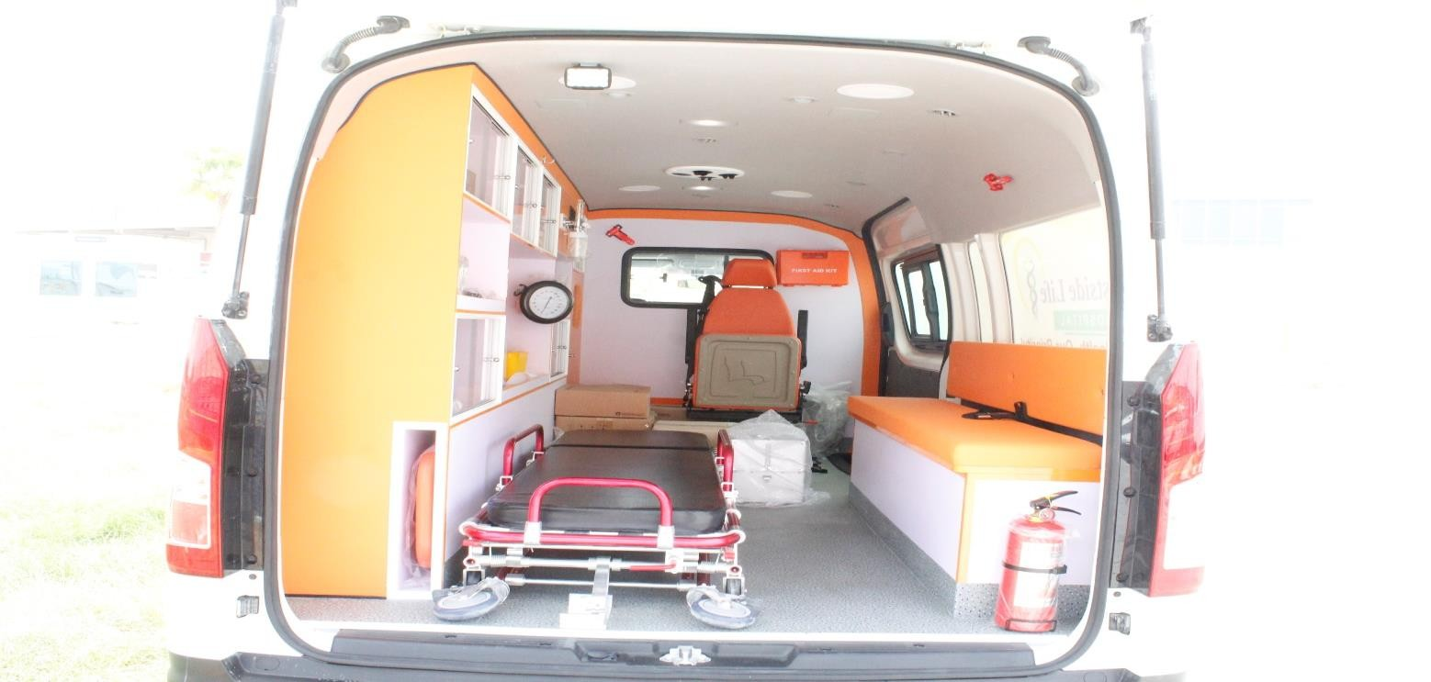
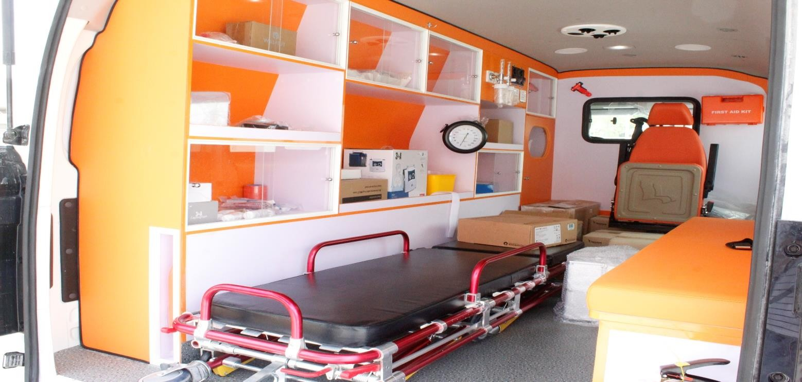

INTERIOR
NOTE: PHOTOS SHOWN ARE FOR REFERENCE ONLY. FINAL PRODUCTION WILL BE BASED ON CLIENT'S REQUEST.

